


Zagazig University
Faculty of Computers and Informatics Computer Science Department

AI-Based Forensic Analysis System for Biometric and Criminal Evidence Identification

BY
- Anas Tamer Mahmoud Ibrahim
- Abdelrahman Sherif Abdelrahman Faris
- Nada Ahmed Wafaei Mohamed Elkafrawy
- Tasneem Mohammed Mohamed Sakr
- Taghreed Mohamed Mahmoud Basuny
- Ahmed Mohamed AbdelQuder Ibrahim

Under Supervision Of
Prof. Mohamed Abdel-Basset Metwally

2025-2026

AI-Based Forensic Analysis System for Biometric and Criminal Evidence Identification
Anas Tamer Mahmoud Ibrahim, Abdelrahman Sherif Abdelrahman Faris, Nada Ahmed Wafaei Mohamed Elkafrawy, Tasneem Mohammed Mohamed Sakr, Taghreed Mohamed Mahmoud Basuny, 6. Ahmed Mohamed AbdelQuder Ibrahim

ABSTRACT

In today’s rapidly evolving world, crimes occur at an unmatched speed, generating vast amounts of complex forensic data such as facial images, DNA sequences, videos, and digital evidence. Despite this rapid growth, forensic analysis remains time-consuming and often relies on fragmented tools, making it difficult for professionals to efficiently manage cases and analyze evidence. which can lead to delays in investigations and increase the risk of missing crucial details that may affect justice’s outcomes. Forensic aims to address these challenges by developing an AI-powered integrated forensic platform designed to support forensic medical professionals. It provides an all-in-one platform that combines advanced analytical tools with case management and collaboration features, enabling users to handle their work more efficiently within a unified environment.
Our project includes several key features powered by artificial intelligence. It offers a deepfake detection model to verify the authenticity of images and videos, a face recognition model for identity verification, a DNA analysis model for processing and analyzing DNA sequences, and an image reconstruction model capable of enhancing images and removing iris-related obstructions to improve visual clarity for Images. Beyond AI models, the platform provides a case management module where users can organize cases and attach evidence, allowing for structured and efficient workflow management. A community section is also included to enable communication between professionals, where they can discuss cases, share knowledge, and stay updated with the latest research. Furthermore, an awareness section is designed for individuals interested in forensic science, providing educational content about forensic practices and the risks of modern crimes, particularly cybercrime.
It utilizes advanced artificial intelligence techniques along with modern software technologies to deliver accurate and efficient results. By integrating multiple functionalities into a single platform, the system reduces reliance on separate tools and enhances overall productivity. The significance of this project lies in its potential to improve forensic investigation processes by reducing analysis time, enhancing accuracy, and supporting collaboration among professionals. Ultimately, it aims to contribute to faster and more reliable justice outcomes while raising awareness about the importance of forensic science in addressing modern crimes.

1. Introduction
1.1 Introduction and Significance
In recent years, the field of forensic science has faced a dramatic increase in the volume and complexity of digital and physical evidence. Modern criminal investigations now rely heavily on diverse data types such as facial images, videos, DNA sequences, and other forms of digital traces. While crimes can occur within seconds, forensic analysis remains a slow and fragmented process, often depending on multiple disconnected tools and systems. This fragmentation creates significant challenges for forensic professionals in managing cases efficiently, analyzing evidence accurately, and maintaining timely investigations.
According to INTERPOL [1], cybercrime incidents have increased significantly over the past decade, with reports indicating that more than 80% of crimes now involve a digital component, including images, videos, or electronic communications. This shift has made digital forensics a core element of modern criminal investigations and has increased the demand for faster and more reliable analytical systems. Additionally, the growing use of manipulated media such as deepfakes poses a serious challenge for forensic experts. Deepfake-related content has been increasing rapidly, with thousands of synthetic videos being generated and shared daily, making the authentication of visual evidence increasingly difficult and critical for ensuring justice. In DNA forensics, global databases now contain tens of millions of DNA profiles, and this number continues to grow as more cases are processed each year. However, despite this growth, forensic laboratories often face significant backlogs, with case processing sometimes taking weeks to months depending on complexity and workload.
Furthermore, forensic professionals frequently deal with fragmented systems and disconnected tools, which slow down analysis and increase operational complexity. This highlights the urgent need for integrated, intelligent, and AI-powered solutions capable of handling multiple types of forensic data efficiently within a unified platform. This project addresses these challenges by developing an AI-powered integrated forensic platform designed to support forensic medical professionals by consolidating essential tools and workflows into a single also the availability of both web and mobile applications enhances system accessibility and usability, allowing users to interact with forensic tools anytime and anywhere.
1.2 Contribution to Scientific Discovery
This project contributes to forensic science by integrating artificial intelligence (AI) into a unified platform that supports the analysis and management of forensic evidence. It addresses the limitation of fragmented forensic tools by combining key functionalities into a single all-in-one system, improving efficiency and accessibility for forensic professionals. The system introduces several AI-based models, including deepfake detection to verify the authenticity of images and videos, face recognition for identity verification, DNA analysis for processing genetic data, and image reconstruction to enhance the quality and clarity of forensic images. These models improve the speed and reliability of evidence analysis compared to traditional manual methods.
The main innovation of the project lies in integrating these AI models with a centralized case management system and collaboration platform. This allows users to manage cases, organize evidence, and communicate with other professionals within one environment, reducing workflow complexity. The project has potential impact in both research and industry by enhancing forensic investigation efficiency, reducing analysis time, and supporting more accurate decision-making. It also contributes to the advancement of AI applications in digital forensics, particularly in evidence verification and biometric analysis.

2. Related Work
Recent advancements in forensic science have introduced a variety of technologies aimed at improving evidence analysis, identity verification, and criminal investigations. These systems typically focus on specific tasks such as face recognition, DNA analysis, or digital media verification, often operating independently rather than as integrated solutions.
In face recognition, Clearview AI [2] uses large-scale image datasets and deep learning for identity matching, achieving high accuracy in ideal conditions. However, it raises serious privacy concerns and performs poorly with low-quality or occluded images, which are common in forensic scenarios. Similarly, Sense Time [3] provides advanced computer vision models with real-time processing capabilities, but it suffers from bias issues and lacks interpretability, making it less suitable for forensic applications that require explainable results. In forensic genetics, Parabon NanoLabs [4] applies DNA-based prediction to estimate facial features from genetic data. While innovative, it produces approximate results and depends on high-quality DNA samples. On the other hand, Othram [5] focuses on DNA sequencing and identification, particularly for degraded samples and cold cases. Despite its effectiveness, it is limited to identity identification and does not integrate with other forensic tools such as face recognition or visual analysis.
Although these solutions demonstrate strong capabilities within their specific domains, they share common limitations. Most systems are specialized for a single task and lack integration with other forensic processes. Additionally, they often prioritize performance in controlled conditions rather than real-world forensic scenarios, such as low-resolution or noisy data. Furthermore, the absence of unified platforms and limited support for collaboration reduce their overall efficiency in practical investigations. This project addresses these gaps by proposing an AI-powered all-in-one forensic platform that integrates multiple technologies within a single system. It combines deepfake detection, face recognition, DNA analysis, and image reconstruction to support comprehensive evidence analysis. The system also focuses on handling challenging forensic data and improving usability through integrated case management and collaboration features. This approach provides a more efficient and practical solution compared to existing fragmented systems.
3. Software Description
3.1 Software Architecture
The architecture of forensic is designed as a modular, scalable, and AI-driven platform that provides an all-in-one solution for forensic professionals and awareness platform for public users. It follows a multi-layered architecture consisting of four main layers: Presentation Layer, Application Layer, AI Layer, and Data Layer as shown in Figure 1.
The system architecture is designed as a multi-layered structure to ensure scalability, flexibility, and efficient integration between components. The Presentation Layer includes both a web application built with Angular, and a mobile application developed using React Native with Expo, providing a consistent and user-friendly experience. Through this layer, users can access key features such as authentication, a dashboard for forensic tools, AI service interfaces (deepfake detection, face recognition, DNA analysis, and image reconstruction), case and evidence management, a community platform, and an AI-powered chatbot. The Application Layer, implemented using Laravel, serves as the core logic of the system. It manages user authentication and roles, handles case and evidence operations, integrates AI models, and supports community features while ensuring security and data integrity. The AI Layer provides automated forensic analysis by integrating multiple models for deepfake detection, face recognition, DNA analysis, and image enhancement, along with an AI chatbot for real-time assistance. Finally, the Data Layer manages structured and unstructured data, including user information, cases, evidence, AI results, and community content, ensuring secure and efficient data storage and retrieval.

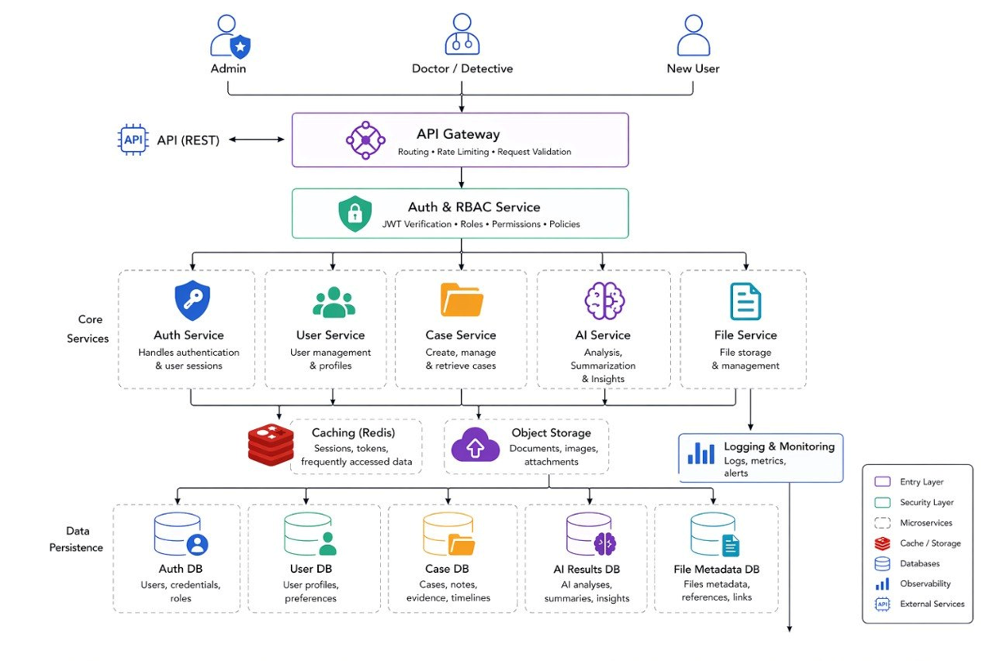
Figure 1 Software Architecture

3.2 Tools and Technologies Used
A variety of tools, frameworks, and technologies were utilized in the development of the Forensic platform to ensure scalability, performance, and efficient system integration. For UI/UX design, tools such as Figma and Adobe Illustrator were used to create user interfaces and interactive prototypes, ensuring a clear and professional user experience.
The frontend development was implemented using Angular, which provides a scalable and structured environment for building dynamic web applications. Additionally, RxJS was used to handle reactive state management and asynchronous operations, enabling efficient data flow within the application. For mobile development, React Native was used to build cross-platform applications for both Android and iOS, while Expo simplified the development, testing, and deployment processes, ensuring consistent user experience across devices. On the backend, Laravel was used as the core framework to manage system logic and API development. Laravel Sanctum was integrated to provide secure authentication and token-based access control, ensuring safe communication between system components.
In the AI and machine learning layer, several models were utilized to support forensic analysis. ResNet50 was used for deepfake detection due to its high performance in image classification tasks. RetinaFace was used for accurate face detection and localization, while ArcFace was employed to generate facial embeddings for reliable identity verification. Additionally, LSTM was used for DNA sequence analysis, and a custom dataset was developed to enhance the accuracy and reliability of the deepfake detection model. For data management and deployment, MySQL was used as a relational database to store structured forensic data, while cloud services such as Azure and Railway were used to ensure scalability, availability, and reliable system deployment.
Other supporting tools included GitHub for version control and team collaboration, Postman for API testing, Kaggle for dataset handling and experimentation, and platforms such as Notion, Miro, and Canva for documentation and system design. The selection of these tools was based on their ability to support system requirements efficiently. Angular was chosen for its scalable frontend architecture, while Laravel provided a secure and well-structured backend environment. ResNet50 was selected for its high accuracy in image-based tasks, while RetinaFace and ArcFace were used to ensure precise face detection and reliable identity verification. Cloud services were used to guarantee scalability and availability and React Native with Expo enabled efficient development of cross-platform mobile applications with a unified codebase and consistent user experience.
3.3 Software Functionalities
The Forensic platform provides an integrated environment that serves both forensic professionals and public users by combining analytical tools, case management, and knowledge-sharing features within a single system. The platform offers AI-based forensic analysis capabilities through multiple models, including deepfake detection, face recognition, DNA analysis, and image reconstruction. These tools enable fast, automated, and accurate examination of different types of forensic evidence, significantly improving the efficiency of investigations. In addition, the system includes a case and evidence management module that allows users to create and manage forensic cases, upload and organize evidence, and link AI-generated results to specific cases. This functionality provides a structured workflow that helps professionals handle investigations more effectively.
The platform also integrates an AI-powered chatbot assistant that responds to forensic-related queries and provides real-time guidance for users. This feature enhances accessibility and supports decision-making by offering immediate assistance when needed. Furthermore, the system includes a community platform where users can share forensic knowledge, discuss cases, and exchange ideas related to digital forensics. This collaborative environment encourages communication between professionals and contributes to continuous learning and knowledge development. To support public awareness, the platform provides educational content, including articles and resources related to forensic science and digital crimes. This helps improve digital literacy and raises awareness about modern forensic challenges. Finally, the system ensures secure user management through role-based access control, distinguishing between forensic doctors and public users. It also implements secure authentication and encrypted data storage, ensuring data protection and controlled access to sensitive information.

4. Methodology
4.1 Data Collection and Preprocessing
4.1.1 Deep Fake Dataset
The deepfake detection module is built using a combination of two datasets to ensure robustness and real-world applicability. The first dataset is the 140K Real and Fake Faces dataset, which contains 70,000 real images collected from Flickr and 70,000 fake images generated using GAN-based models. The second dataset is a private Video Frames Dataset, which consists of frames extracted from videos to better simulate real-world deepfake scenarios. All images were resized to a fixed input size of either 224×224 or 256×256, and the datasets were then split into training, validation, and testing sets. Several preprocessing steps were applied to improve model performance and generalization, including image resizing, data augmentation techniques such as horizontal flipping and rotation, conversion of images into tensor format, and normalization using standard mean and standard deviation values. The training data was augmented to enhance variability, while the validation data was only resized and normalized to ensure a fair and unbiased evaluation of the model.
4.1.2 Face Recognition Dataset
A customized dataset was created for the face recognition module, consisting of facial images of multiple individuals, with approximately 50–60 images per person. The dataset includes variations in pose, lighting conditions, and appearance to ensure diversity and improve the robustness of the model. It is organized locally using a folder-per-person structure, where each folder represents a specific individual and contains their corresponding images [7]. Several preprocessing steps were applied to prepare the data for training and inference. First, images are loaded and converted into RGB format. Then, face detection is performed using RetinaFace, which also extracts key facial landmarks. The detected faces are validated by filtering out low-quality detections based on confidence score, face size, and image coverage to remove incorrect or unreliable results. After that, face alignment is applied using eye landmarks to ensure consistency across samples. The aligned face region is then cropped with minimal background. Finally, images are resized, padded if necessary, and normalized to meet the model requirements, and each processed face is converted into a 512-dimensional embedding vector for feature representation.
4.1.3 DNA Dataset
The DNA analysis module is built on a curated dataset consisting of 41 Single Nucleotide Polymorphisms (SNPs) associated with externally visible characteristics. The dataset was collected from the NCBI dbSNP database using the human reference genome (GRCh38). Each SNP includes detailed surrounding sequence information (flanking regions) as well as allele data, which enables accurate genotype extraction without the need for full genome alignment [8].
Several preprocessing steps were applied to prepare the genetic data for model input. First, DNA input is parsed and converted into a consistent format. Next, sequence cleaning is performed to remove invalid entries and properly handle DNA strand orientation. SNP matching is then conducted by locating the exact SNP positions using the provided flanking regions. After that, genotype extraction is performed to identify the corresponding alleles for each SNP. Finally, the extracted genotypes are converted into numerical representations through feature encoding, making them suitable for input into the machine learning model.
4.1.4 Image Reconstruction Dataset
The forensic face enhancement module is built using three pre-trained models, each trained on specialized datasets to improve restoration and super-resolution performance. The primary face restoration model, GFPGANv1.4, was trained on the Flickr-Faces-HQ (FFHQ) dataset, which contains 70,000 high-quality face images with a resolution of 1024×1024 [9]. For background enhancement and general image super-resolution, RealESRGAN was trained on a combination of datasets, including DIV2K (800 high-quality 2K images), Flickr2K (2,650 high-quality images collected from Flickr), and the Outdoor Scene Training (OST) dataset, which contains 10,324 outdoor images across multiple categories. In addition, the UTKFace dataset was used as a supporting dataset, consisting of over 20,000 face images annotated with age and gender information, further improving model robustness across diverse facial characteristics.
For preprocessing, uploaded images in formats such as JPG, PNG, WebP, BMP, and TIFF are loaded using PIL and converted into RGB format to ensure consistency across inputs. The normalized images are then saved in a unified format before being passed through the enhancement pipeline, where they undergo restoration and super-resolution to improve overall facial clarity and image quality.
4.2 Model Development
4.2.1 Deep Fake Model
The deepfake detection model is built on a pretrained ResNet-50 architecture, which has been modified by adding a fully connected layer for binary classification to distinguish between real and fake images. Transfer learning is applied to enhance performance while reducing training time and computational cost. The model workflow begins with image loading and conversion into a standard format, followed by face detection and alignment to ensure consistency. The detected face region is then extracted through cropping. After preprocessing, the model performs feature analysis using multiple cues, including frequency patterns, texture inconsistencies, noise artifacts, color distortions, and compression artifacts. These extracted signals are then aggregated to produce the final prediction, classifying the input as either real or fake. During training, a batch size of 64 is used with a learning rate of 1e-4. The dataset is divided into training, validation, and testing sets to ensure proper evaluation. The model is optimized through fine-tuning of pretrained weights using backpropagation, allowing it to effectively adapt to the deepfake detection task. The model performance is evaluated using standard classification metrics such as accuracy, ensuring reliable detection of manipulated media.
4.2.2 Face recognition Model
The face recognition module is based on the ArcFace framework, which generates a 512-dimensional embedding vector for each detected face to enable identity verification. In the early stages of development, the system relied on a pretrained ResNet-18 model modified with a fully connected layer for multiclass face classification. Although this approach performed adequately on small datasets, it showed limitations in scalability as the number of identities increased. To address this issue, the system was upgraded to ArcFace with a ResNet-34 backbone. Instead of directly classifying identities, this approach learns highly discriminative facial embeddings, allowing faces to be compared efficiently using similarity measures and enabling the system to scale to a larger number of users. The model is configured with a ResNet-34 backbone and takes an input size of 112 × 112 × 3. It produces 512-dimensional embeddings using an angular margin of 0.5 and a feature scale of 64 to enhance class separability. Training is performed using SGD with momentum (0.9), a learning rate of 0.1 with scheduled decay, and a weight decay of 5 × 10⁻⁴. The model is trained with a batch size of 512 over 24 epochs. For identity verification, the similarity between two faces is computed using cosine distance between their embeddings, allowing the system to determine whether they belong to the same individual.
4.2.3 DNA Phenotyping Model
At the early stage of development, the system focused on genotype identification from DNA sequences. Several machine learning models were tested for this task, and LSTM achieved the best performance among them due to its ability to handle sequential biological data. As the project evolved, we adopted a research-based forensic DNA phenotyping approach. The flanking sequences used for SNP detection were obtained from the human reference genome assembly through the NCBI dbSNP database. The final DNA phenotyping module parses DNA sequences and applies published statistical models used in forensic genetics to predict externally visible characteristics (EVCs). The system implements three multinomial logistic regression models and a Bayesian ancestry estimator The DNA phenotyping module applies three established prediction models. IrisPlex is used for eye color prediction, where the input consists of 12 binary features derived from 6 SNPs, and the output is classified into Blue, Intermediate, or Brown (reference). For hair color prediction, the system uses HIrisPlex, which takes 44 binary features derived from 22 SNPs and predicts one of four classes: Blond, Brown, Red, or Black (reference). Finally, skin color prediction is performed using HIrisPlex-S, which uses up to 82 binary features derived from 41 SNPs and produces one of the following output classes: Very Pale, Pale, Intermediate, Dark, or Dark-to-Black. These models rely on fixed coefficients derived from large population genetic studies, making them reliable for forensic applications. In general, prediction accuracy is highest for extreme phenotypes (such as blue eyes, red hair, and very dark skin), often achieving AUC values above 0.90.
4.2.3 Image Reconstruction Model
It implemented using an ensemble of three pre-trained deep learning models, each optimized for a specific enhancement task. The main restoration model is GFPGANv1.4, which is responsible for recovering missing facial details and improving facial clarity. This model was originally trained on the Flickr-Faces-HQ (FFHQ) dataset, For improving the overall image background and increasing resolution, the module integrates RealESRGAN, which was trained using a combination of multiple general-purpose datasets including DIV2K, Flickr2K, and the Outdoor Scene Training (OST) dataset. In addition, demographic attribute estimation is supported using the UTKFace dataset, which contains over 20,000 face images annotated with age and gender.
The enhancement process follows a structured pipeline. First, the input image is ingested and normalized by converting it into RGB format and saving it temporarily as JPEG to ensure consistent processing. Second, face restoration is performed using GFPGAN, where faces are detected and aligned using landmark-based affine transformations. The aligned face crops are then passed through the GAN restoration network to reconstruct fine facial features such as skin texture, eyes, and hair. After restoration, the enhanced faces are warped back to their original positions and blended into the background. Third, a validation stage filters out false-positive face detections to avoid incorrect demographic predictions. Finally, demographic estimation is performed using DeepFake, where age and gender are predicted through an ensemble approach using multiple detector backends (RetinaFace, OpenCV DNN, and MTCNN). Valid predictions are averaged to improve robustness, and the final age result is mapped into predefined forensic age brackets. The implementation focuses on integrating and optimizing the inference pipeline rather than training from scratch. The ensemble-based approach improves reliability in real forensic conditions by enhancing low-quality facial evidence while also providing additional forensic attributes such as age range and gender estimation.
4.3 Implementation
The implementation process started with collecting, understanding, and preparing the datasets required for the system. After preprocessing the data, we began developing the AI models. These models were continuously improved and refined over time to achieve better performance and reliability. After that, the backend development started alongside the UI/UX design. The backend was responsible for handling system logic, managing data, and connecting the platform with the AI models, while the UI/UX design focused on creating a clear and user-friendly interface. In parallel, the frontend of the website was developed using Angular, where the main system features were implemented and connected to the backend APIs. At the same time, work was ongoing on developing the application to ensure consistent user experience across platforms. Finally, all components were integrated together, including the AI models, backend services, and frontend interface. The system was tested to ensure proper functionality and smooth interaction between all modules.

5. Results and Discussion
5.1 Model Performance
The performance of the proposed Forensic platform was evaluated across its four AI modules: deepfake detection, face recognition, DNA phenotyping, and image reconstruction. Standard evaluation metrics including accuracy, precision, recall, and F1-score were used to assess the classification models. Experimental results demonstrated that the proposed deepfake detection model based on ResNet-50 achieved an accuracy of 99.52%, precision of 99.52%, recall of 99.52%, and F1-score of 99.52% on the testing dataset. Similarly, the ArcFace-based face recognition model achieved a verification accuracy of 95% with strong discrimination between identities. The DNA phenotyping module produced reliable predictions for eye, hair, and skin color traits, while the image reconstruction module significantly improved image quality and facial clarity in low-resolution forensic images.

Modal name | Accuracy | Precision | Recall | F1_score
Deepfake detection | 99.52% | 99.52% | 99.52% | 99.52%
Face Recognition | 95% | 95% | 95% | 94%
DNA Phenotype | 98.36% | 95.49% | 97.45% | 96.40%
Gender classification | 87% | 87% | 87% | 87%

5.1.1 Deep Fake Model
The learning behavior of the deepfake detection model was further analyzed using training and validation accuracy and loss curves. The curves demonstrated stable convergence throughout the training process, with both training and validation performance improving consistently and without significant signs of overfitting, indicating strong generalization capability on unseen data. To further evaluate classification performance, a confusion matrix was generated to visualize the distribution of true positives, true negatives, false positives, and false negatives. The confusion matrix showed that the model correctly classified most real and fake samples, with only a limited number of misclassifications. In addition, a classification report was used to assess precision, recall, and F1-score for each class. The obtained results revealed high precision and recall values for both real and fake categories, confirming the model's effectiveness in detecting manipulated media and demonstrating its reliability for forensic evidence verification.
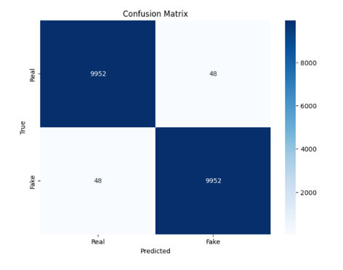 | 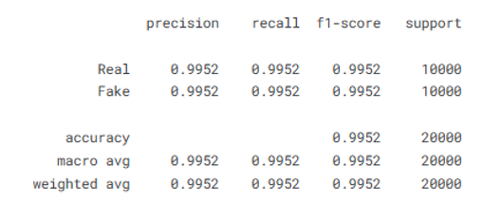

Figure 2 Confusion Matrix Figure 3 Classification Report

5.1.2 Face recognition Model
The performance of the face recognition model was further evaluated using verification accuracy, cosine similarity analysis, and embedding-space discrimination metrics. The training and validation results showed stable convergence, indicating that the ArcFace framework successfully learned highly discriminative facial representations while maintaining good generalization capability. To analyze recognition performance in detail, a confusion matrix was generated to visualize correctly and incorrectly identified identities across the test set. The confusion matrix revealed a high number of correct matches and a very low rate of identity confusion, demonstrating the model's strong capability to distinguish between different individuals. Furthermore, a classification report was used to evaluate precision, recall, and F1-score for identity classification tasks, providing a comprehensive assessment of recognition performance. The results showed consistently high scores across all metrics, confirming the robustness of the proposed face recognition module. Additionally, the integration of RetinaFace for face detection and alignment contributed to improved recognition accuracy under variations in pose, illumination, and facial appearance, making the model suitable for real-world forensic identity verification scenarios.
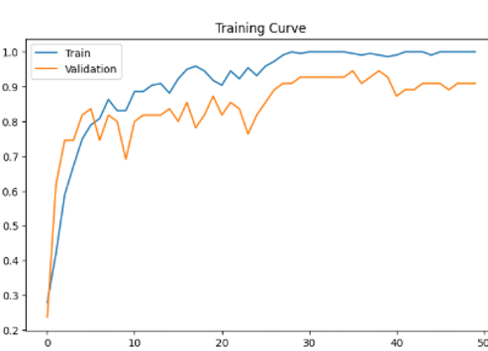

Figure 4 Learning Curve
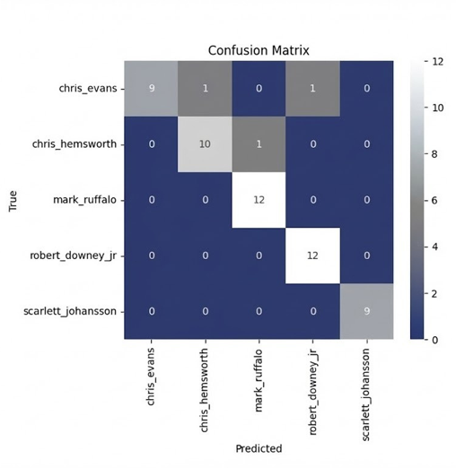 | 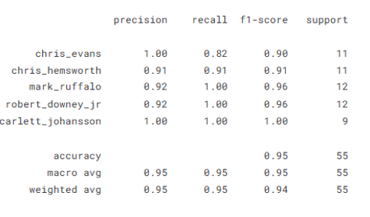

Figure 5 Confusion Matrix Figure 6 Classification Report

5.1.3 DNA Phenotyping Model
The performance of the DNA phenotyping module was evaluated by comparing seven machine learning classifiers, namely Gradient Boosting, Random Forest, Decision Tree, Logistic Regression, K-Nearest Neighbors (KNN), Naïve Bayes, and Support Vector Machine (SVM). Each classifier was trained and tested using the encoded SNP features extracted from the DNA dataset to determine its ability to accurately predict externally visible characteristics. Among the evaluated models, Gradient Boosting achieved the best overall performance, outperforming the other classifiers in terms of prediction accuracy and classification consistency. Random Forest and SVM also demonstrated strong results, while Decision Tree, Logistic Regression, KNN, and Naïve Bayes showed comparatively lower performance due to their limited ability to capture complex relationships within the genetic data. To further analyze the prediction results of the best-performing model, a confusion matrix was generated to visualize the distribution of correctly and incorrectly classified samples across all phenotype categories. The confusion matrix revealed that most predictions were concentrated along the main diagonal, indicating a high number of correct classifications and relatively few misclassifications between phenotype classes. These findings confirm the effectiveness of the Gradient Boosting classifier for forensic DNA phenotyping and demonstrate its suitability for extracting meaningful biological characteristics from genetic markers, thereby supporting forensic investigations and human identification tasks.
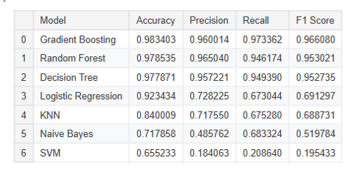 | 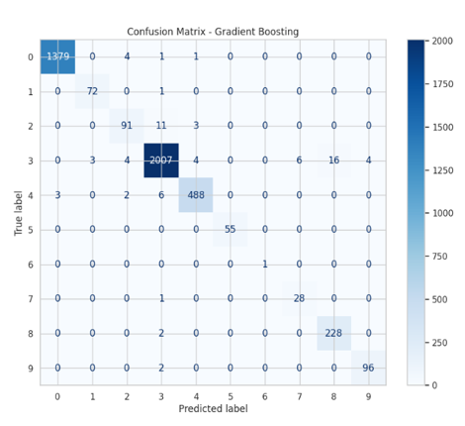

Figure 7 Models Accuracy Figure 8 Confusion Matrix

5.1.4 Image Reconstruction Model
The performance of the image reconstruction and demographic estimation module was evaluated using age-group and gender classification tasks after the image enhancement process. Following reconstruction with GFPGAN and RealESRGAN, the enhanced facial images were analyzed to estimate age and gender attributes. To assess the effectiveness of the demographic prediction stage, separate confusion matrices were generated for age-group classification and gender classification. The age confusion matrix showed that most samples were correctly assigned to their corresponding age categories, with a limited number of misclassifications occurring primarily between neighboring age groups due to similarities in facial appearance. Similarly, the gender confusion matrix demonstrated a high rate of correct male and female classifications, indicating reliable demographic estimation after image restoration. In addition, classification reports were generated for both tasks to evaluate precision, recall, and F1-score. The results revealed consistently strong performance across the evaluated classes, with gender prediction achieving particularly high precision and recall values, while age-group prediction maintained robust performance despite the greater complexity of estimating age from facial characteristics. These findings demonstrate that the proposed enhancement pipeline not only improves the visual quality of degraded forensic images but also preserves and enhances critical facial features required for accurate age and gender estimation, making it a valuable tool for forensic image analysis and investigative support.
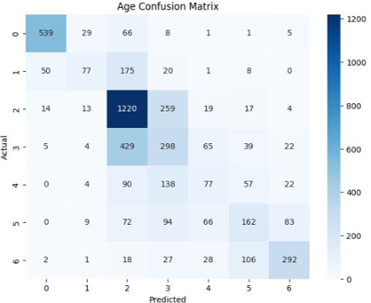

Figure 9 Confusion Matrix

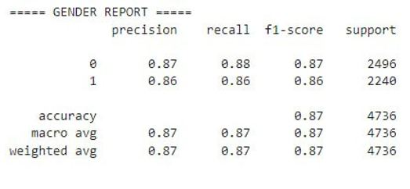 | 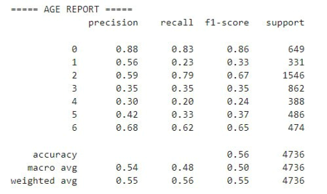

Figure 10 Classification Report For Gender Figure 11 Classification Report For Age

5.2 Interpretation of Results
The obtained results demonstrate the effectiveness of integrating multiple AI-powered forensic analysis tools within a unified platform. The deepfake detection model achieved high classification performance due to the use of transfer learning and extensive preprocessing techniques, enabling reliable detection of manipulated media. Likewise, the ArcFace-based face recognition model provided robust identity verification even under varying lighting conditions and facial poses, making it suitable for real-world forensic scenarios.
Compared with existing forensic solutions such as Clearview AI, SenseTime, Parabon NanoLabs, and Othram, the proposed platform offers a broader range of functionalities by combining deepfake detection, face recognition, DNA phenotyping, image enhancement, case management, and professional collaboration within a single environment. While many existing systems focus on a specific forensic task, the proposed platform provides an integrated workflow that reduces operational complexity and improves investigation efficiency. The results also indicate that preprocessing techniques such as face alignment, image normalization, and data augmentation contribute significantly to model performance. Overall, the findings confirm that the proposed platform can support forensic professionals by delivering accurate evidence analysis, reducing processing time, and enhancing decision-making during investigations.

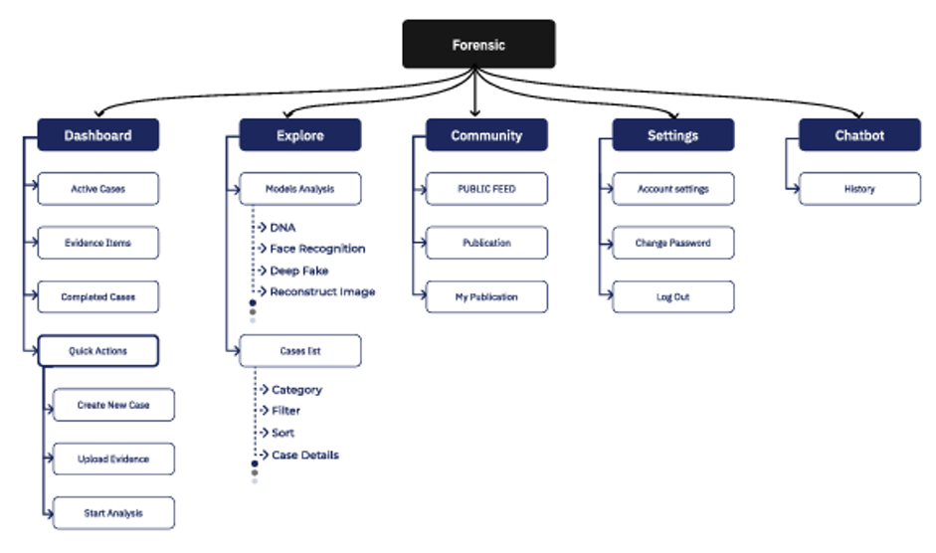
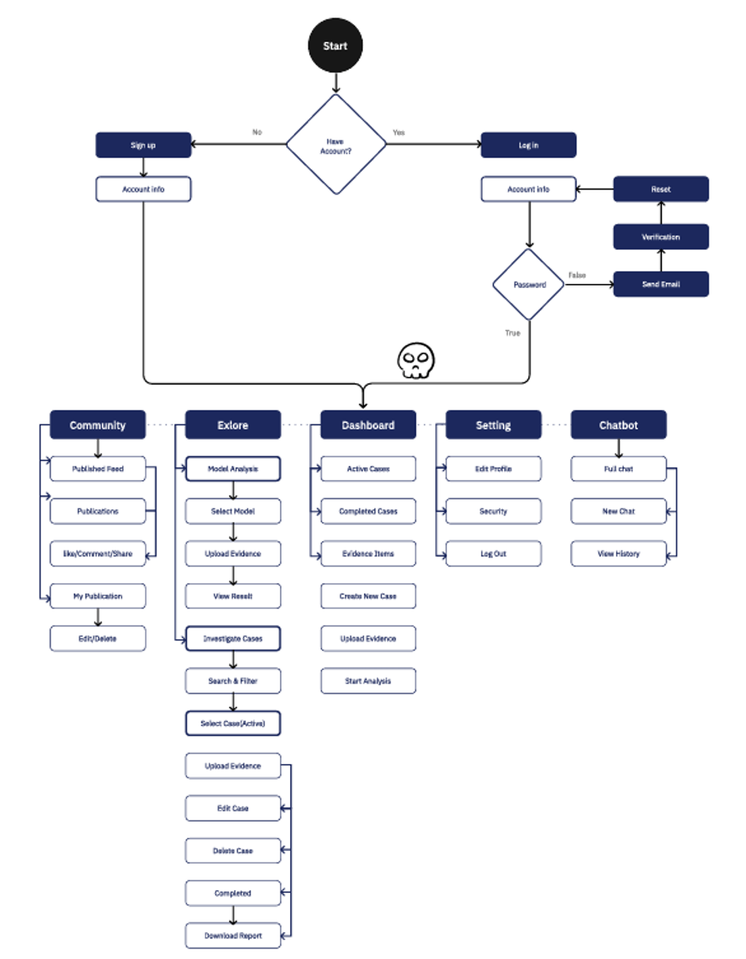
6. Illustrative Examples
Forensic is designed with three main user paths: administrators, who manage and monitor the system, public users, who access awareness and educational content, and forensic doctors, who represent the primary target audience. In this section, an illustrative example is presented to demonstrate the typical workflow of a forensic doctor while using the platform. After signing in, the doctor is redirected to the dashboard, which provides an overview of key statistics related to their cases and evidence. The dashboard also offers quick access to frequently used actions, helping streamline daily forensic tasks next, the doctor can view a list of their active cases and select a specific case to review its details. Within the case page, the doctor can examine previously uploaded evidence or upload additional evidence files.
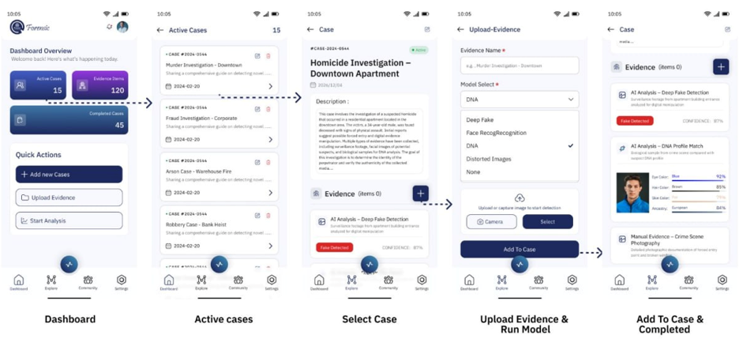
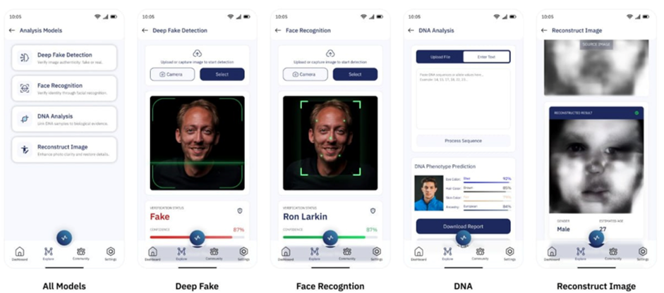
Once the evidence is uploaded, the doctor can choose one of the available AI tools to analyze it. The platform provides four main forensic models: Deepfake Detection, Face Recognition, DNA Analysis, and Image Reconstruction. After running the selected model, the generated results can be stored directly and linked to the related case for future reference. Forensic includes an internal professional community, where doctors can publish research findings, share conclusions, and view contributions from other forensic experts. Finally, the doctor can use the integrated chatbot assistant to ask forensic-related questions, receive guidance, or get support during investigative tasks.
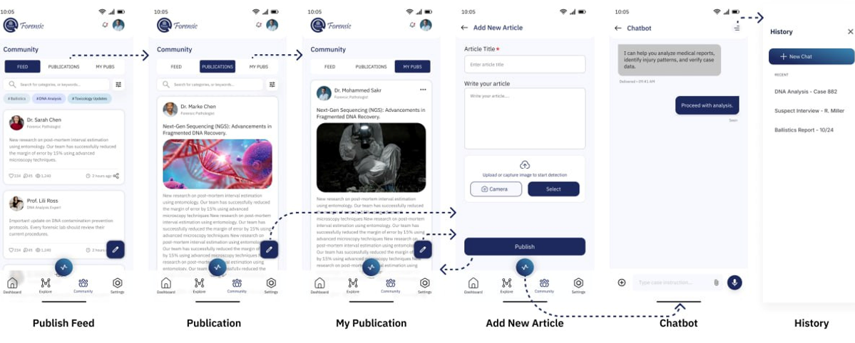
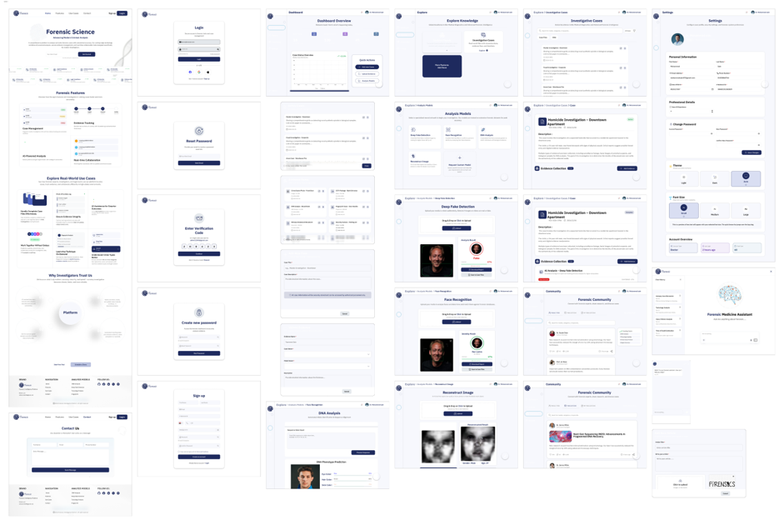
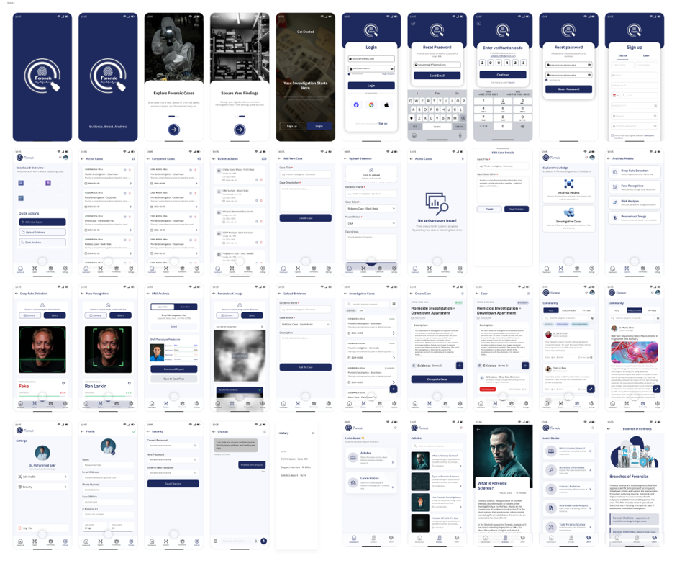
7. Impact
7.1 Target Audience
Forensic is designed to serve two main user groups: forensic medical professionals and public users interested in forensic awareness. It provides a comprehensive environment that combines AI-powered analysis tools with knowledge-sharing and educational resources. Forensic doctors are the primary users of the system. The platform supports them in analyzing medical and biological evidence such as DNA data and facial images. It enables them to detect patterns, verify identities, and validate the authenticity of digital evidence using AI models. In addition, the system provides case management tools and a collaborative environment, helping professionals organize their work efficiently and reach accurate, scientifically reliable conclusions.
Public users also benefit from the platform through its awareness and educational features. The system offers access to a community space and a content library that includes articles and educational materials related to forensic science and digital manipulation. Users can ask questions, interact with others, and gain a better understanding of topics such as deepfake risks and media authenticity. By addressing the needs of both professionals and general users, the platform bridges the gap between advanced forensic technologies and public awareness. It enhances the efficiency of forensic investigations while promoting knowledge and understanding of modern forensic challenges.

7.2 Innovative Aspects of the Design
Forensic integrates advanced AI technologies within a unified system architecture to deliver a comprehensive and efficient forensic solution. The platform employs multiple AI-driven modules, including deepfake detection, face recognition, DNA analysis, and image reconstruction, enabling accurate and efficient analysis of diverse types of forensic evidence. Unlike traditional solutions that focus on isolated tasks, Forensic is designed as an all-in-one integrated platform that combines AI-based analysis, case management, evidence handling, and community interaction within a single environment. This integration reduces system complexity and significantly improves workflow efficiency for users.
The system also includes an AI-powered assistant (chatbot) that supports both forensic professionals and general users by answering questions and providing insights related to forensic analysis and digital evidence interpretation. In addition, the platform incorporates an awareness and knowledge component that offers educational content and a community space for discussing forensic science topics and understanding the risks of digital manipulation. These innovations collectively enhance existing forensic solutions by providing a more integrated, efficient, and accessible approach to investigations. The platform not only improves the accuracy and speed of evidence analysis but also bridges the gap between professional forensic tools and public awareness.
7.3 Reliability
Forensic system is designed to ensure reliable performance when handling forensic data and generating accurate analysis results. By integrating multiple AI models within a unified platform, it reduces reliance on manual processes and minimizes human error as the AI models were trained and continuously improved using prepared datasets. The system was also tested with different input types to verify consistent performance. Integration testing was conducted to ensure smooth communication between the frontend, backend, and AI services. Additionally, input validation and secure data handling mechanisms were implemented to reduce errors and protect sensitive forensic data. Overall, it provides a stable and dependable environment for forensic analysis.
7.4 Added Value
Forensics provide significant value for forensic professionals, researchers, and the wider community. For forensic doctors, it offers an all-in-one environment that simplifies workflows by combining evidence analysis, case management, and collaboration tools, leading to faster and more accurate investigations. For researchers, the system supports the advancement of AI applications in forensic science by integrating multiple analysis models and utilizing a custom-built deepfake dataset. This can contribute to further research in areas such as digital evidence verification and biometric analysis. In the industry, the platform can enhance operational efficiency in forensic laboratories by reducing analysis time and improving decision-making processes. It also introduces a more modern, technology-driven approach to forensic investigations. Additionally, the system has future potential for expansion by integrating more advanced AI models, improving analysis accuracy, and supporting additional types of forensic data. It can also be extended to support mobile platforms and real-time analysis features.
8. Conclusions
In Forensic, we developed an AI-powered integrated forensic platform designed to support forensic professionals and enhance public awareness. The system combines multiple features, including AI-based evidence analysis, case and evidence management, a community platform, and an intelligent chatbot, providing a complete all-in-one forensic environment. The platform improves the efficiency and accuracy of forensic investigations by enabling faster analysis of different types of evidence such as images and DNA data. It also bridges the gap between advanced forensic technologies and public understanding through its awareness and educational features. During the development process, several challenges were encountered, including data preparation, improving model performance, and integrating multiple system components into a unified platform. Addressing these challenges provided valuable insights into building scalable AI systems and handling real-world forensic data. In conclusion, this project highlights the potential of artificial intelligence in modern forensic science. With further improvements and the integration of more advanced models, the system can play an important role in supporting forensic investigations and promoting awareness of digital forensic challenges.
9. Future Directions
Future work can focus on improving the performance and accuracy of the existing AI models through training on larger and more diverse datasets. Additionally, more advanced models can be integrated to support a wider range of forensic analysis tasks. and enhance the public user module by expanding awareness features, improving educational content, and increasing user interaction within the platform.

References
[1] INTERPOL. (n.d.). Cybercrime. INTERPOL
[2] Clearview AI. (n.d.). Overview. Clearview AI.
[3] SenseTime. (n.d.). SenseTime. SenseTime
[4] Parabon NanoLabs. (n.d.). Parabon NanoLabs. Parabon NanoLabs
[5] Othram. (n.d.). Othram. Othram.
[6] 40k Real and Fake Faces dataset. (n.d.). Kaggle.
[7] Deep Fake dataset. (n.d.). Hugging Face
[8] DNA Sequence Prediction dataset. (n.d.). Kaggle
[9] UTKFace dataset. (n.d.). Kaggle

